Лабораторна робота 3

Глуховський Ігор

https://github.com/Kartoz9/NodeJs

1. Nodemon

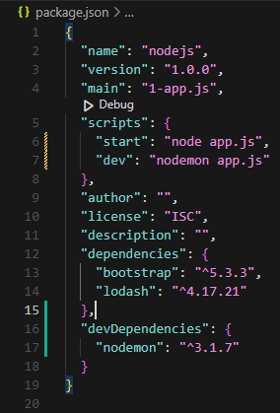

1. Event Loop

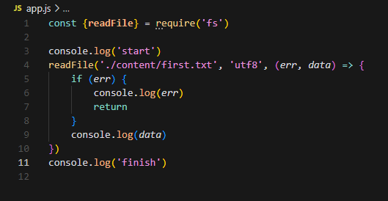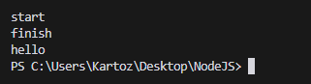

1. Async Patterns – Blocking code

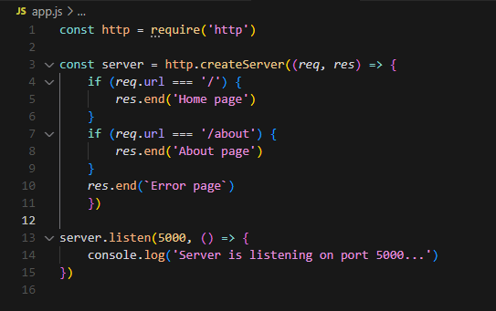

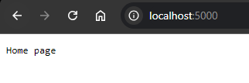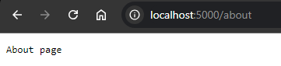

1. Async Patterns – Setup promises

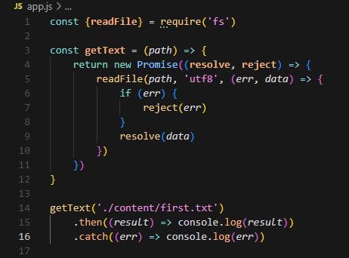



1. Async Patterns – Refactor to Async

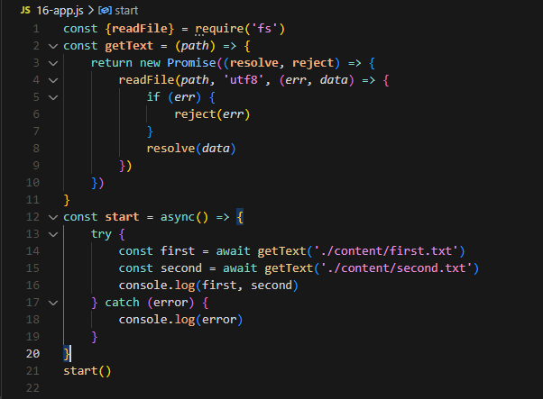 

1. Async Patterns – Node`s Native Option

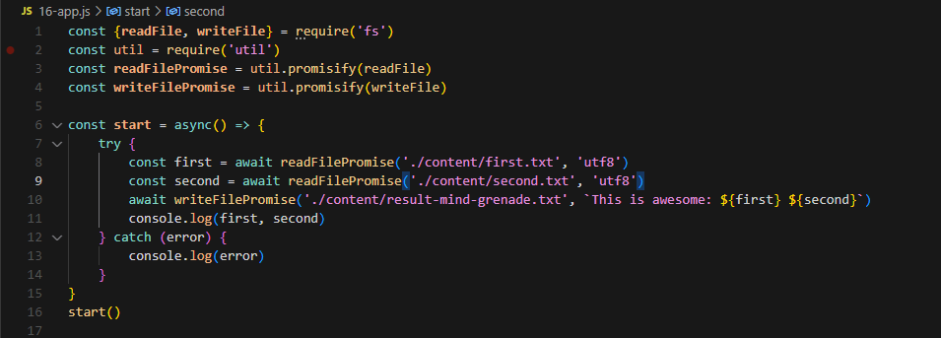

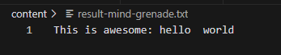

1. Events Emitter

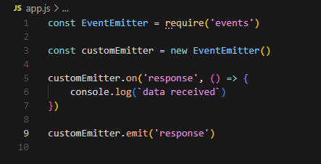 

1. Events Emitter – Additional Info

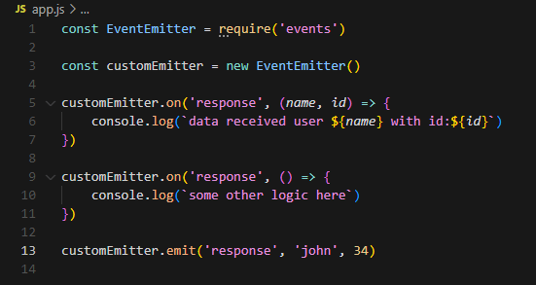 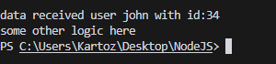

1. Streams – Read File

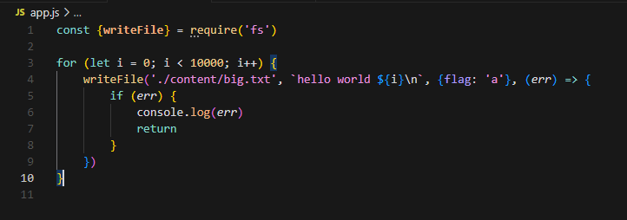 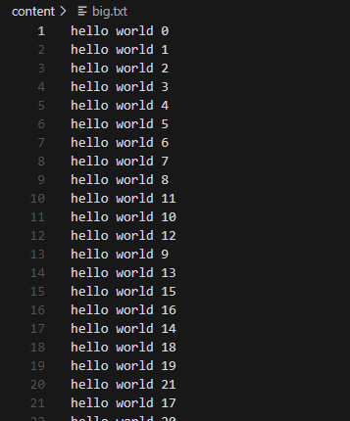

1. Streams – Additional Info

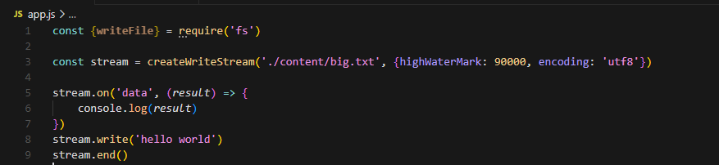

1. Streams – HTTP Example

